* [Docs](https://geonetwork-opensource.org/manuals/trunk/en/index.html) »
* [Administrator guide](https://geonetwork-opensource.org/manuals/trunk/en/administrator-guide/index.html) »
* [Configuring the catalog](https://geonetwork-opensource.org/manuals/trunk/en/administrator-guide/configuring-the-catalog/index.html) »
* System configuration
* [Edit on GitHub](https://github.com/geosource-catalogue/doc/blob/develop/source/administrator-guide/configuring-the-catalog/system-configuration.rst)

**System configuration**

Most of the system configuration parameters can be changed by administrator users using the web interface in Admin console > Settings.

Important

Configuration of these parameters is critically important for the catalog in an operational context. Misunderstanding some settings may result in a system that does not function as expected. For example, downloads may fail to be correctly processed, or metadata harvesting from other servers may not work.

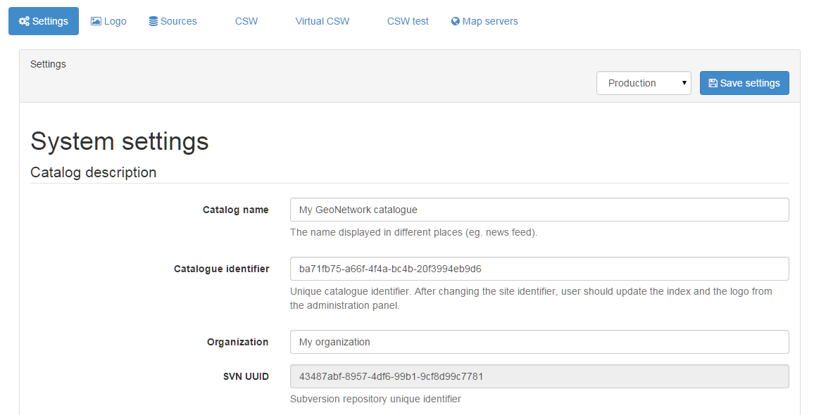

Since the settings form is a long form, the ‘save’ button is repeated between the sections and will save all settings.

**Catalog description**

* **Catalog name** The name of the node. Information that helps identify the catalogue to a human user. The name is displayed on the banner, in the CSW GetCapabilities.
* **Catalog identifier** A universally unique identifier (uuid) that distinguishes your catalog from any other catalog. This a unique identifier for your catalogue and its best to leave it as a uuid. It will be used by harvester using GeoNetwork protocol to identify the source catalog.
* **Organization** The organization the node belongs to. Again, this is information that helps identify the catalogue to a human user.
* **SVN UUID** Subversion repository attached to the node. This identifier is created and/or checked on startup to verify that the database match the SVN repository. The repository is used for metadata versionning.

**Catalog**

* **Version** The version of the catalog (readonly, version of the database)
* **Minor version** The minor version of the catalog (readonly, version of the database)

**Catalog Server**

* **Host** The node’s name or IP number (without [http://](NULL)). For example, they are used during metadata editing to create resource links and when returning the server’s capabilities during a CSW request.
* If your node is publicly accessible from the Internet, you have to use the domain name.
* If your node is hidden inside your private network and you have a firewall or web server that redirects incoming requests to the node, you have to enter the public address of the firewall or web server. A typical configuration is to have an Apache web server on address A that is publicly accessible and redirects the requests to a Tomcat server on a private address B. In this case you have to enter A in the host parameter.
* **Port** The server’s port number (usually 80 or 8080). If using HTTP, set it to 80.
* **Preferred Protocol** Defined the protocol to access the catalog. The HTTP protocol used to access the server. Choosing http means that all communication with the catalog will be visible to anyone listening to the protocol. Since this includes usernames and passwords this is not secure. Choosing https means that all communication with the catalog will be encrypted and thus much harder for a listener to decode.
* **Secure Port** The secure port number.
* **Log level** Define the logging level of the application. After modification, log can be checked in the Statistics & status section under Activity.

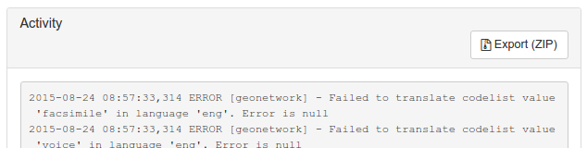

**Intranet parameters**

A common need for an organisation is to automatically discriminate between anonymous internal users that access the node from within an organisation (Intranet) and anonymous external users from the Internet. The catalog defines anonymous users from inside the organisation as belonging to the group *Intranet*, while anonymous users from outside the organisation are defined by the group *All*. To automatically distinguish users that belong to the Intranet group you need to tell the catalog the intranet IP address and netmask.

* **Netmask** The intranet netmask (eg. 255.255.255.0).
* **Network\*** The intranet address in IP form (eg. 147.109.100.0).

**Z39.50**

* **Enable Z39.50 Server** Enable Z39.50 server. Restart the catalog to make this change active.
* **Port** Change the Z39.50 listening port. Restart the catalog to make this change active.

**Proxy server**

The settings page offers to set the configuration of a proxy server. This configuration is used by the application to access the internet to get online resources, for example as part of a harvest proces.

* **Use proxy** Enable the proxy in case the catalog is behind a proxy and need to use it to access remote resources.
* **Proxy Host** The proxy IP address or name
* **Port** The proxy port
* **Proxy username** The username
* **Proxy user password** The username password
* **\*Ignore host list** To bypass specific hosts enter a specific IP address or host name such as www.mydomain.com or an address range using wildcards, such as 192.168.2.*. Use | to separate the different host values.

JVM proxy parameters may also be required to properly set the proxy for all remote access.

There is also another context in which the concept of a proxy is used. GeoNetwork can use a [Web Proxy](https://developer.yahoo.com/javascript/howto-proxy.html) to prevent cross site scripting errors. These days using [CORS](https://www.w3.org/TR/cors/) is a better approach to manage cross site scripting, however some data providers may not yet support CORS yet. Use a security rule in [config-security-mapping.xml](https://github.com/geonetwork/core-geonetwork/blob/3.4.0/web/src/main/webapp/WEB-INF/config-security/config-security-mapping.xml#L42) to define which domains are allowed access by the GeoNetwork proxy.

**Feedback**

Email may be sent by the catalog.

* you are using the User Self-registration system
* you are using the metadata status workflow (See [Life cycle](https://geonetwork-opensource.org/manuals/trunk/en/user-guide/workflow/life-cycle.html#life-cycle))
* a file uploaded with a metadata record is downloaded and notify privilege is selected

This section configure the mail server to use.

* **Email** This is the administrator’s email address used to send feedback.
* **SMTP host** The mail server name or IP address to use for sending emails.
* **SMTP port** The SMTP port.
* **Use SSL** Enable SSL mode
* **User name** Username if connection is required on the SMTP server
* **Password** Username password if connection is required on the SMTP server

**Metadata search results**

Configuration settings in this group determine what the limits are on user interaction with the search results.

* **Maximum Selected Records** The maximum number of search results that a user can select and process with the batch operations eg. Set Privileges, Categories etc. This parameter avoid to trigger long action which could generate out of memory error.